- Download the Q ParentConnection app from your Play Store.
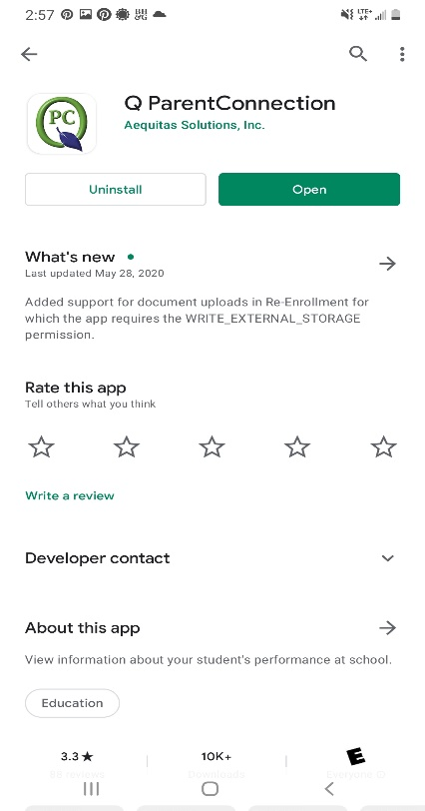

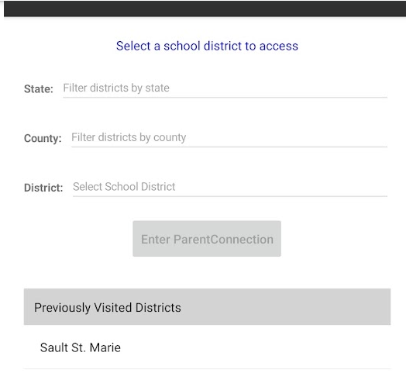
- Once you have downloaded the app, you will be directed to select our school district (Sault St. Marie) by entering our State and County.

- Once you have selected Sault St. Marie as your district, you will see a welcome page. Select Log In.
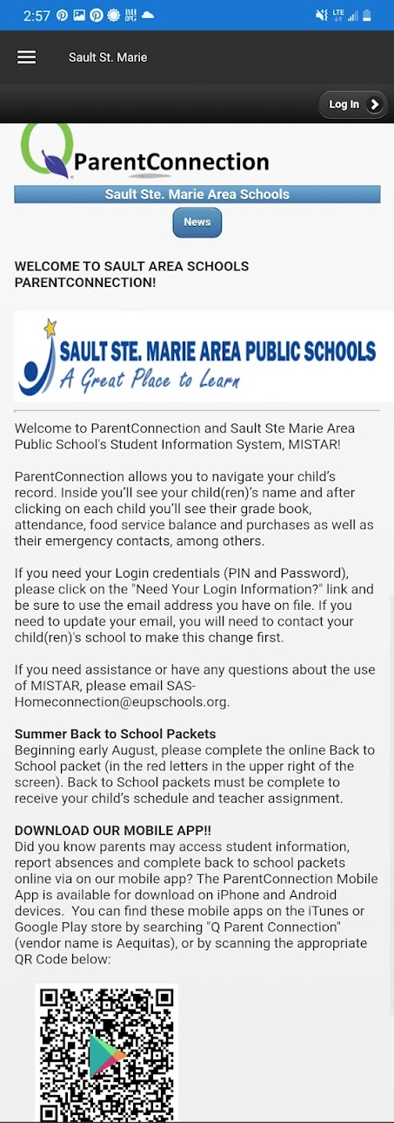

- Enter your pin and password
If your child is a returning student, you should have received a pin and password already. If your child is new to the district, you should have received an email from DONOTREPLY@saultschools.org with this information. The email could be in your spam folder. If you did not receive an email, please call 906.632.5686.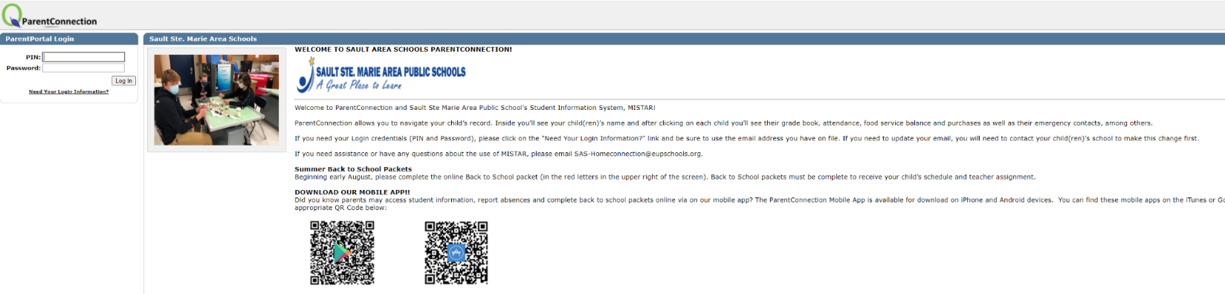

- You will be able to see your student(s).
